Gwendolyn Hill Biography

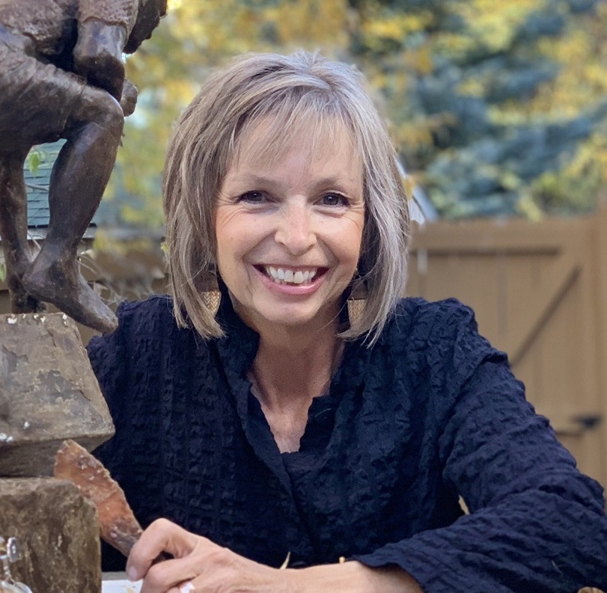
art@gwendolynhill.netgwendolynhill.net

Gwendolyn was born and raised near Boulder, Colorado, with her four siblings in an area that had recently transitioned from coal mining to an urban and trendsetting environment. It was here at the age of ten that the ability to sew was introduced while sitting at the kitchen table helping her mother piece patterns together and mend garments. This valuable knowledge taught her how to connect materials to complete a polished product. Today, you can see this in her wall sculptures, which incorporate acrylic, leather, fabric, metals, wire, and textiles.

At her childhood home, she would accompany her father to his woodshed as he made furniture and toys for his kids. This also had a profound impact on Gwen’s artwork later in life.

Later in her fourties, to gain understanding of sculpting the figure, she was mentored by Don Huntsman, of Aspen, Colorado as well as Russian sculptor Simon Kogan at the Scottsdale Artist’s school. These mentors gave her a unique sense for layering, weaving, constructing, and using line which had an everlasting impact on how she creates today.

